HOMETOWN HERO BANNER PROGRAM

Central Steuben Chamber of Commerce is sponsoring a Hometown Hero Banner program.

Each individual banner will be unique and honor a specific “Hometown Hero” who has served or is currently serving our country. The red, white, and blue banners will feature the name of the service person, their branch of service and a photo of the veteran or service member. The banner will be the same design on both sides.

The Hometown Hero Banners will be displayed throughout the village of Bath. All banners will be placed randomly. We cannot accommodate placement requests at this time. This program is designed to honor those men and women who have served our country through military service.

The cost of each banner is $200. The number of banners that we can currently put up is limited. Purchases will be accepted on a first-come, first-served basis. Any applicant that cannot be accommodated will be placed on a waiting list. We will also be working to expand the number of banner display places in the future.

Banners will be displayed for three years with an option for renewal at that time. Contributions toward the program will also be accepted.

Please make checks payable to Central Steuben Chamber of Commerce. Mail or hand deliver completed application, photo, and payment to Lake Country Jewelry & Coins, 6 West Steuben Street Bath, NY, 14810. Applications may be dropped off Monday-Friday 9:30-5 and Saturday 9:30-1. Please be sure that photos are labeled with the service person’s name. If a return address is included, every effort will be made to return the original photo to the sponsor.

For more information please contact the Chamber Office at (607) 776-7122.

HOMETOWN HERO BANNER PROGRAM

PLEASE PRINT CLEARLY
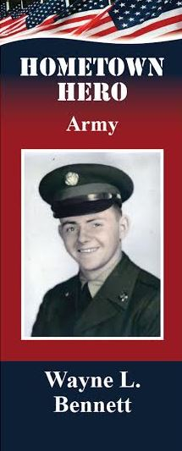
Full Name of Person in Photo:______________________________
Branch of Service: (circle one) Army Navy
Air Force Marines Coast Guard
Killed in Action? (please check here)_____
Name of Person Submitting photo:____________________________
Relationship to Hometown Hero:______________________________
Phone Number:_________________________
Address:_________________________________________________
_________________________________________________________
Email Address:___________________________________________

PHOTE RELEASE FORM
I hereby grant Central Steuben Chamber of Commerce permission to use the attached photo (which includes a likeness of myself or of my relative) in the Hometown Hero Banner Program. In addition, I take full responsibility that all information provided about the veteran being honored is accurate and correct.

Signature:_________________________________ Date:____________________
Printed Name:________________________________________________________

